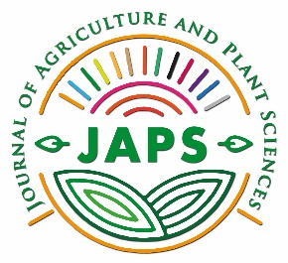 | Editorial office: Journal of Agriculture and Plant Sciences,  Faculty of Agriculture, Goce Delcev University, Stip,  Krste Misirkov 10A, 2000, Stip, Republic of North Macedonia  Editors:  liljana.gudeva@ugd.edu.mk; emilija.arsov@ugd.edu.mk; fidanka.trajkova@ugd.edu.mk  Administrator: biljana.atanasova@ugd.edu.mk http://js.ugd.edu.mk/index.php/YFA

AUTHOR/S STATEMENT

Under the full moral and substantive responsibility, I/We declare that the paper titled _________________________________________________________________________, which has been submitted for publication to the Editorial Board of the Journal of Agriculture and Plant Sciences Volume ___ Number __:

- Is a result of individual research conducted in an ethical and responsible manner that comply with the relevant legislation;
- The results are presented, honestly and without fabrication, falsification or inappropriate data manipulation;
- The paper has not been published or accepted for publication elsewhere;
- All authors have significantly contributed to research.

Permission notice

Authors are expected to obtain permission from copyright holders for reproducing any illustrations, tables, figures or lengthy quotations previously published elsewhere. The Journal will not be held accountable for any copyright infringement caused by the authors.

Copyright notice

The content offered in the Journal remains the intellectual property of the authors and their publishers respectively. Goce Delcev University – Stip keep the right to promote and re-publish the texts.

Date____________________
Author/s Signature
1.__________________________
2.__________________________
3.__________________________
4.__________________________

Contact author information
Name and surname:
Institution:
E-mail:

The signed Author/s Statement shall be forwarded in PDF format to the following e-mail address: japs@ugd.edu.mk

